15 Cisco Device Management

- Lab Exercise

In this lab you will perform a factory reset, password recovery, configuration backup, and system image backup and recovery on a Cisco router. You will also perform an IOS upgrade on a Cisco switch.

Use Cisco Packet Tracer for this exercise. The generic server in Packet Tracer (as shown in the topology diagram below) has built-in TFTP server software.

Lab Topology

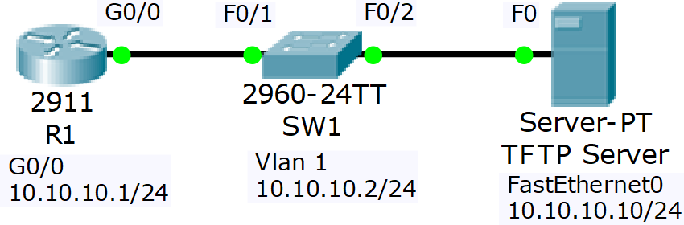

Load the Startup Configurations

Open the ‘15 Cisco Device Management.pkt’ file in Packet Tracer to load the lab.

Factory Reset

- View the running configuration on R1. Note that the hostname and interface have been configured

- Factory reset R1 and reboot

- Watch the boot up process as the router boots

- The router should boot into the Setup Wizard. Exit out of the wizard and then confirm the startup and running configurations are empty.

- Paste the configuration for R1 from the ‘15 Cisco Device Management Configs.zip’ file back into the configuration and save

Password Recovery

- Set the enable secret ‘Flackbox1’ on R1

- Configure the router to boot into the rommon prompt on next reload, and reboot the router. In a real world scenario you would enter the Break sequence on the keyboard when first powering up the router to access the rommon prompt

- Configure the router to ignore the startup-config when booting up, and reload the router

- The router should boot into the Setup Wizard. Exit out of the wizard

- What do you expect to see if you view the running and startup configurations? Confirm this.

- Copy the startup config to the running config. Do not miss this step or you will factory reset the router!

- Remove the enable secret

- Ensure the router will reboot normally on the next reload and you will be able to access the router

- Reboot the router to confirm

Configuration Backup

- Backup the running configuration to Flash on R1. Use a suitable name for the backup file. Verify the configuration has been backed up.

- Backup the R1 startup configuration to the TFTP server. Use a suitable name for the backup file. Verify the configuration has been backed up.

IOS System Image Backup and Recovery

- Backup the IOS system image on R1 to the TFTP server. Verify the configuration has been backed up.

- Delete the system image from Flash and reload.

- Use Internet search to find system recovery instructions for your model of router. Recover the system image using the TFTP server.

- If you are using the latest version of Packet Tracer the download will time out because the GigabitEthernet interface stays down in rommon mode. You have completed this part of the lab once you have entered the tftpdnld command.

IOS Image Upgrade

- Verify SW1 is running C2960 Software (C2960-LANBASE-M), Version 12.2(25)FX

- Use the TFTP server to upgrade to C2960-lanbasek9-mz.150-2.SE4.bin

- Reboot and verify the switch is running the new software version

